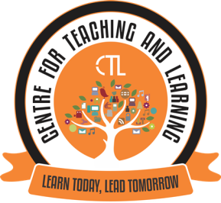
AUGUST-2020 ( Monthly Report-CTL)

The Centre for Teaching Learning (CTL), powered by IQAC in the month of August, 2020 conducted Expert FDP webinar series II on “Effective Online teaching Learning Evaluation” on 10th August, 2020 for the college faculty. Ms. Priya Lotlikar, Research Scholar, Department of Educational Technology, IIT Bombay was the resource person for this FDP. This FDP focussed on Transitioning to online Instruction (from face to face classroom): towards creating Learner- Centric Environment. FDP was attended by around 50 college faculty. Apart from the FDP series CTL Team worked in designing a Course schedule template, setting tasks and time lines and also suggested guidelines for execution and review of the tasks in view of online teaching learning.

CTL also organised a training session on "Chunking” conducted by Dr. Sameena Falleiro, Associate Professor in the Department of Computer Science and the Coordinator CTL on 5th and 6th August, 2020 from 11:00 am to 12:00 pm ( 1 hour duration) in the Flipped Learning classroom. The CTL is also involved in conducting one on one hands-on training sessions for the college faculty on Multimedia Editing S/W led by the Mr. Andrew Barreto, Assistant Professor, Co-Coordinator CTL.

The Launch of "EVidya", "Harnessing Knowledge, Igniting Minds" an Online Teaching Learning Initiative of Parvatibai Chowgule College of Arts and Science, Autonomous, Margao Goa for the Academic Year 2020-2021 was held on 31st August, 2020 at 10.30am via Google Meet for all the college teaching staff. With the eLaunch of eVidya, Chowgule College aims to deliver quality eContent to the students.

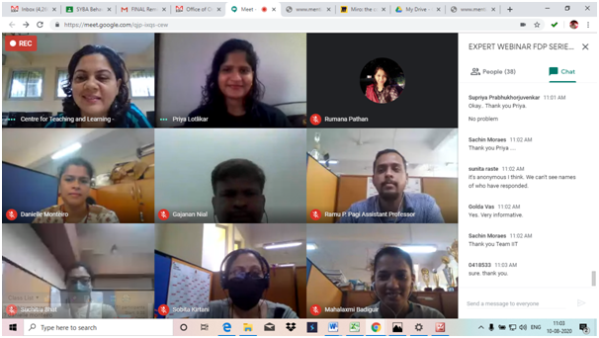
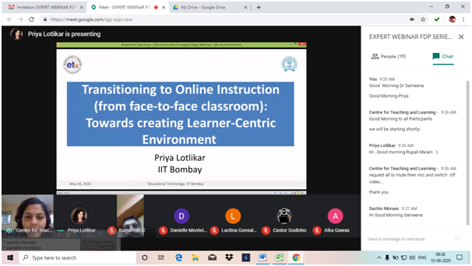
Expert FDP Webinar Series II (August10th, 2020)

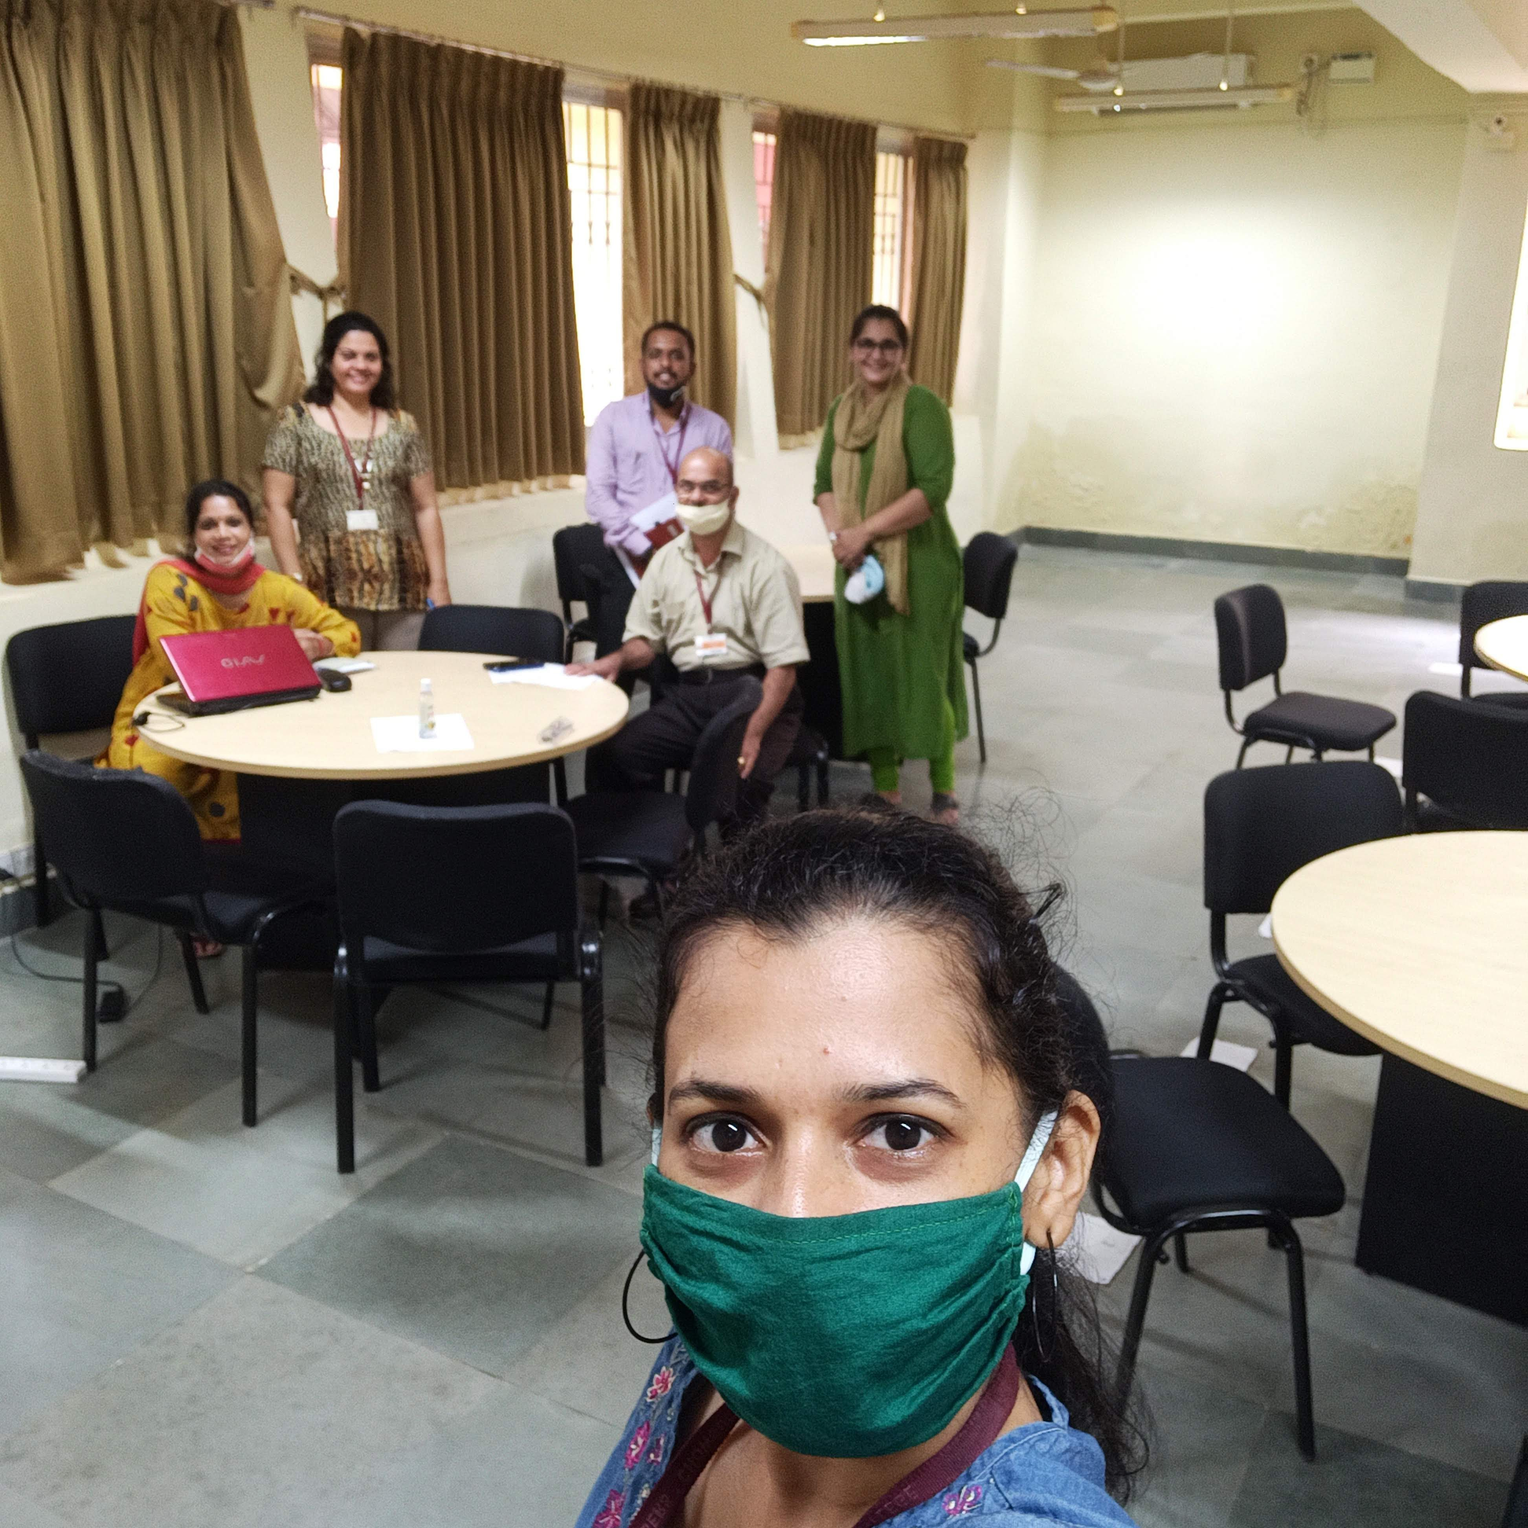
Training session on “Chunking” conducted by Dr. Sameena Falleiro, Associate Professor, Coordinator CTL

